Bayes’ Theorem – Naïve Bayes Theorem

Spanners, 2 machine produce spanners

Whats the probability of Machine 2 producing a faulty spanner?

Information Given –

M1 : 30 wrenches/hr

M2: 20 wrenches/hr

Out of all the produced parts: 1% of them are defective

Out of all defective parts – 50% come from M1, 50%come from M2

What is the probability that a part produced by M2 is defective ?

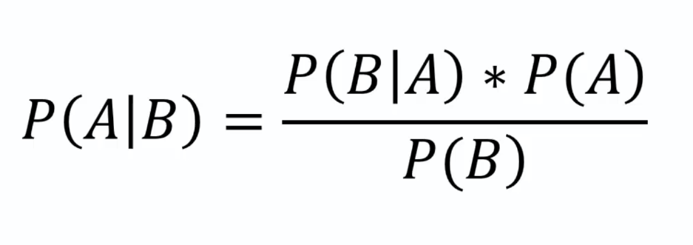Probability Formula.

* P(m1) = 30/50 = 0.6
* P(m2) = 20/50 = 0.4
* P(Defect) = 1%
* P(M1 | Defect) = 50%
* P(M2 | Defect) = 50%
* P(Defect | M2) = ?

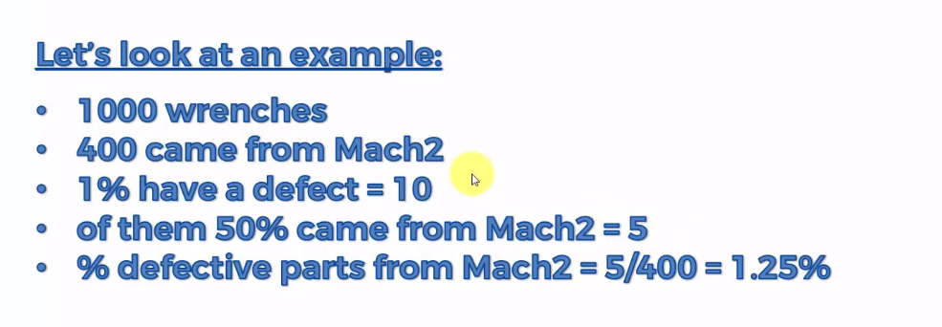P(Defect|M2) = $\frac{P\left(M2 | Defect\right)*P(Defect)}{P\left(M2\right)}$ = 0.0125 = 1.25%

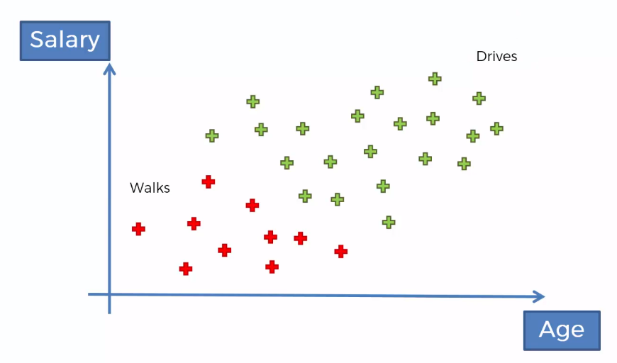Naïve Bayes Classifier Intuition (Supervised Machine Learning Algorithm)

Plan of Attack

* 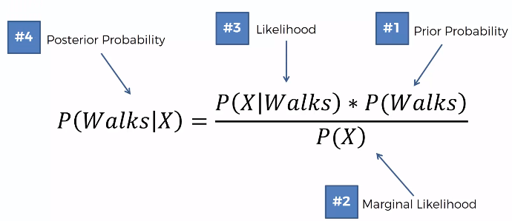P(Walks|X) = $\frac{P\left(X | Walks\right)*P\left(Walks\right)}{P\left(X\right)}$
* P(Drives|X) = $\frac{P\left(X | Drives\right)*P(Drives)}{P\left(X\right)}$
* 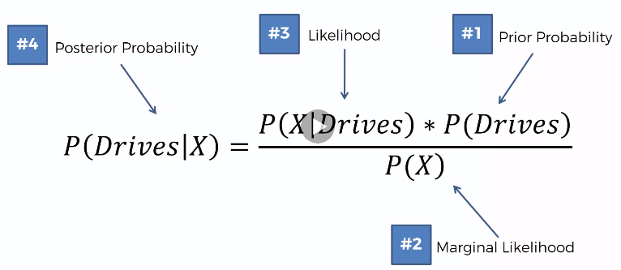P(Walks|X) vs P(Drives|X)

Step 1

* P(Walks) = $\frac{Number of Walkers}{Total Observations}$ = $\frac{10}{30}$
* Have an input radius and Draw a circle around the observation (Select on your own), Deem all the points are similar in terms of features to the points we have and what is the P(X)
* P(X) is what is the likelihood of any new random dataset falling into the circle drawn. 4/30
* P(X|Walks) what is the likelihood that somebody who walk has the feature X. Draw the circle again.
* P(Walks|X) will be 0.75

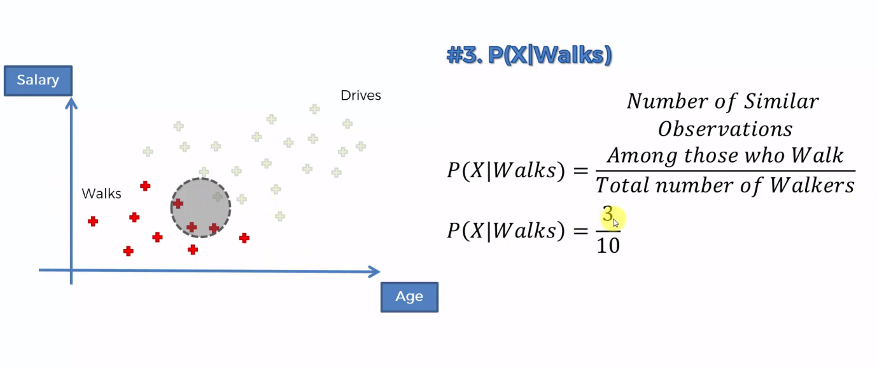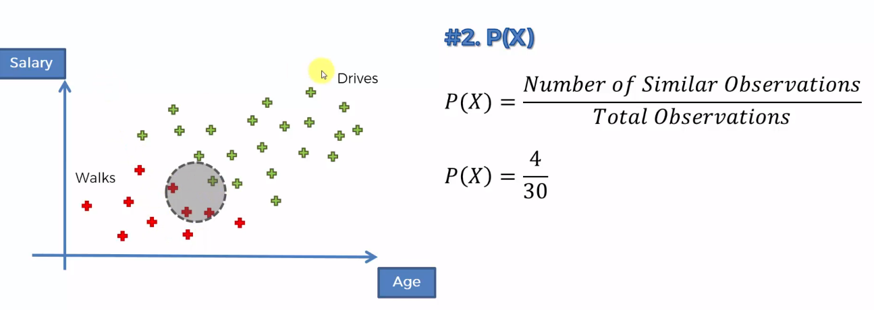

1. Why Naïve?

Independence Assumptions. Which are often times not correct. The variables are usually not independent

1. P(X)? If only comparing the 2 then P(X) may be omitted but If you want to calculate the actual value then you need the P(X)
2. What if there are more than 2 Classes?